Turn-key Specification

DevelopmentAddress:_________________________________________________________________
No. Of Beds: ____________ Size:________SQM/SQFT
The following details must be provided;
Building Structure: (please select)
Masonry Timber Frame Other ______________________Specify

Windows: (please select)
Timber Aluminium PVC Aluclad Other _________________Specify
(Preference is for PVC )
NOTE: In all first-floor windows and above ensure safety restrictors are present.

Internal:
Kitchen specification: – Please specify counter and door finishes ________________________
_______________________________________________________________________________

Tiled Floor finishes to be provided in the areas below NOTE: All floor tiles to comply with current regulation slip resistance rating for that area.
- Bathroom
- Kitchen (to include dining room area if within the same room space)
- Utility room
- WC
- Ensuite (where provided)
- Accessible toilet
- All other floors should be skimmed concrete finish
Tiled Wall Finishes required in the areas below Note: Entire area should have a tanking system applied after tiling a silicone bead is to be applied in corners and where wall tiles meet floor tiles to prevent leaks.
- Bathroom
- Kitchen Splash back
- Ensuite splash back above WHB and around shower area if present. (where provided)
- Accessible toilet tiled Splash back above WHB
NOTE: Tiled splash backs above WHB should cover the width of the basin and approx. 300mm in height, It should be trimmed with tile trim and a bead of silicone applied between WHB and base of tiles.
Bathroom
Shower doors/ bath screen to be installed.
Shaver lights
Mirror

Other provisions:
All external doors to be fitted with Thumb turn locks.
All internal doors to be of solid timber construction. (no glass)
All internal doors to be provided with door stops.
Internal doors into WCs, Bathrooms and en-suites to be fitted with thumb turn locks.
All isolation valves in Hot press/control rooms must be clearly tagged.
All Kitchen/Utility room isolation switches to be clearly labelled.
Kitchen Extractor fans to be fitted in Kitchen above hob.
Fire blanket to be fitted in kitchen at head height in clear view.

Attic: Please note the following;
- Attics not to be floored unless planning application indicates attic storage to comply with CDP storage provisions.
- Walkway to water tank from attic hatch to be provided.
.
External:

Side Gate (where applicable)
Front and rear external lighting
Rear garden – topsoil raked and seeded for lawn
Front garden – topsoil raked and seeded for lawn
Wired in interconnected smoke/heat/fire alarms throughout as per current electrical regulations
Carbon monoxide Alarm in areas required as per current electrical regulations.
Preference for “Hit & Miss” type fencing as opposed to shiplap fencing

Safety File (see attached Safety File spec)
Should be sufficiently compiled with all requisite documents as follows:
Testing Certificates
O & M Manuals
Details of all subcontractors and their input
Prompt delivery of safety file to the Council on completion of project (required prior to closing)
Developer to provide an induction to the first tenant at the time of handover of the safety file
There should be separate safety file for each house
Services:
Provide details on;
Primary heating: (Where unit has chimney, survey report & dvd to be furnished, Certification of smoke test required)
Please provide commissioning certification and proof of warranty for heating system installation.
____________________________________________________________________________________
Please note that heat pumps are to be sited away from the house structure so as to negate against vibrations and noise.
Renewable technology:_________________________________________________________________________
Ventilation:___________________________________________________________________________
Alarms:
Smoke Alarms to be provided as( per current electrical regulations.)
Carbon Monoxide Alarms to be provided ( per current electrical regulations.)
Do not wire up for intruder alarm unless already present.
Certification of Compliance with all aspects of the Building Regulations to be provided.

Assessment under DHPLG best practice guidelines manual, ‘Quality Housing for Sustainable Communities’
Complete design assessment for each house/apartment type being proposed.
Dwelling: House type xx x bed/ xx person x storey.
Accommodation | Target Floor. Areas (min.) | Provision | Min. width  (min.) | Provision | Comment  √ or X
Gross Floor Area |  | m² | Overall area is calculated under CDP standards below as it exceeds DHPCLG manual standards
Living Room |  | m² |  | m²
Agg. Living Area |  | m²
Bedroom 1*  (main bedroom) |  | m² |  | m²
Bedroom 2 (Double) |  | m² |  | m²
Bedroom 3 (double) |  | m² |  | m²
Bedroom 4 (single) |  | m² |  | m²
Agg. Bedroom Area |  | m² | n/a
Accessible toilet at GF.
(Statutory requirements for access for people with disabilities as set out in Part M – TGD Building Regulations).
Assessment under Kildare County Development Plan 2017-2023, Development Management Standards.
Min. Req’mts  (xxx Bed House) | Target (m²) | Provision (m²) | Comment  √ or X
Floor Area |  | m²
Storage |  | m²
Private Open Space |  | m²
Advisory Notes.
County Development Plan - Policy 17.4.5 (Development Management Standards) requirement.
Storage.
- Storage should be additional to kitchen presses and bedroom furniture, but may be partly provided in these rooms.
(If storage provisions are to be proposed in such rooms, the plans shall clearly indicate
in addition any such wardrobe/kitchen press unit provisions in each respective room)
- General Storage provision should be provided on each floor.
- Storage should be provided off a hallway or landing to facilitate access.
- Hot presses or boiler space do not count as general storage areas.
- As a rule, no individual storage room within a dwelling should exceed 3.5 sq metres.
- Dwellings may provide storage for bulky items outside individual units and this may satisfy part of the general storage requirement.
Important Note:
This guidance document is only intended to help assist designers in completing their design accordingly, however this document is not a substitute for the DHPCLG guideline manual titled ‘Sustainable Urban Housing; Design Standards for new Apartments’ 2015, and designers shall ensure their design complies fully with this guidance document.
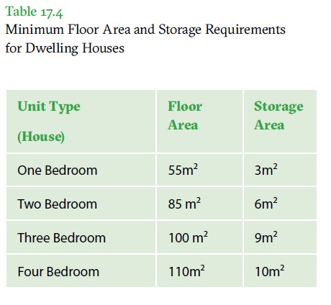
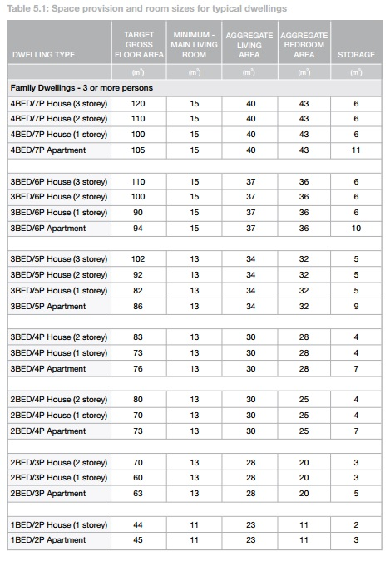

Part V Design Assessment Template
Space provision & room sizes for Typical Apartments.
N.B. Please complete space provision and room size template for each unit type to be delivered:

Apartment types are defined in terms of the number of bedrooms being proposed.
Please refer to DHPCLG guideline manual titled ‘Sustainable Urban Housing; Design Standards for new Apartments’ March 2018, for full details on apartment classification & design requirements.

Example Apartment: 1 Bedroom.
Assessment carried out in accordance with DHPCLG ‘Sustainable Urban Housing; Design Standards for new Apartments’ March 2018.
Accommodation | Target Flr. Areas (DoEHLG/KCC) | Provision |  | Min. width | Provision | Comment  √ or X
Gross Floor Area | 45m² | m²
Living/Dining area | 23m² | m² |  | 3.3m | m²
Agg. Living Area | 23m² | m²
Bedroom | 11.4m² | m² |  | 2.8m | m²
Agg. Bedroom Area | 11.4m² | m²
Storage | 3m² | m²
Private Amenity | 5m² | m² |  | 1.5m | m²
Accessible toilet -
(Part M-Building Regulations)

Important Note:
This guidance document is only intended to help assist designers in completing their design accordingly, however this document is not a substitute for the DHPCLG guideline manual titled ‘Sustainable Urban Housing; Design Standards for new Apartments’ 2018, and designers shall ensure their design complies fully with this guidance document.

Contents of Safety File

As per the responsibilities of the PSCS set out under Regulation 21 of the “Safety, Health & Welfare at Work Regulations 2013”; the following shall be included in the Safety File, in a soft copy , clearly labelled on the outside, with a contents page, and with each section clearly sub-divided. All warranties to be previously registered by the contractor prior to handover of Safety File, and documentary proof of registration to be included in the Safety File.
The safety file is to be used as a source for information held by the ‘Client’ in a user friendly format, for anyone who is likely to carry out work on or around the building. The completed Safety File must be received by Kildare County Council prior to the sale being concluded.
All hard copy operation and maintenance manuals must be left in the property in a presentable manner for the occupants.

Property Address:

Property Planning Reference No: _______________________
Section A: Building Control Compliance 2014

- Certificate of compliance - design …………………………………………………………

- Certificate of compliance – completion ……………………………………………………
Both Assigned Certifier & Builder Ancillary Certificates
- Structural compliance certificate ………….…………………………………………………

- Fire regulations certificate of compliance…………………………………………………

- Electrical certificate of compliance …………………………………………………………

- Mechanical certificate of compliance ………………………………………………………

General: (tick √ app.)
Copy of this Contents sheet issued with the contract documents…………………………
Copy of as built drawings of the property, highlighting all services to and from the property and any other relevant information (boundary lines, underground cables etc.. )

Details of all sub-contractors who worked on the project, together with……………
details of their works (single A4 typed page will suffice).
Details of PSDP, PSCS, and Designers including any specialist designers involved …
in the project.

Drawings:
Copy of as-built drawings of the property;
- Highlighting all services to and from the property ………………………………………
- As-built plans, elevations and sections including building services ………..……
- Site plan identifying the particular property ………………………………………………

CCTV survey of waste and storm drains servicing the property, up to the property

Copy of Waste Disposal landfill receipt………………………………………………………………

Materials:
Building Specification; including all details of materials used in the property, to include manufacturer and supplier/ installer

Certification from supplier that Hardcore sub-base contains no Pyrite………………..

Copy of concrete cube-test results………………………………………………………………………

Heating System:
Certificate of testing of overall heating system, signed by certified heating
Contractor
(App F of KCC Spec’ or similar)

a) Oil Fired Heating System
Passport for newly installed Oil Boiler, together with commissioning and testing
certificates.
Registered warranty for newly installed oil boiler………………………………………

Oil Boiler O&M Manual………………………………………………………………………………..

Servicing certificate of oil boiler by certified maintenance contractor …………
(App D of KCC Spec’ or similar)

Basic schematic showing heating system including valves, pumps and controls

b) Gas Fired Heating System
Certificate of installation of new gas boiler (Cert 3), together with ……………
commissioning and testing cert’s, signed by RGI contractor.
O&M manual for new gas boiler………………………………………………………………..

Registered warranty for newly installed gas boiler……………………………………….

Servicing certificate of existing gas boiler by RGI contractor (RGI Cert 3)……..

Basic schematic showing heating system including valves, pumps and controls

c) Stoves
Design certificate for stand-alone stove, together with installer’s certificate…
and registered warranty.

Design certificate for dual-heating stove, together with installer’s certificate……
and registered warranty.

d) Alternative Primary Heating
(Air to water heat pump/ Ground source heat pump/ group heating scheme, etc.. )
Certificate of installation of new heat pump, together with ………………………….
Commissioning and testing cert’s, signed by registered contractor.
O&M manual for new heat pump………………………………………………………………..

Registered warranty for newly installed heat pump…………………………………….

Induction received by KCC rep on the operation and maintenance of the system…

Summary of Maintenance Requirements
Identification of forecasted/ periodic maintenance with the property, this is to identify timelines for maintenance or servicing for all technologies included in the property – primary heating, renewable technologies and any other predicted areas requiring attention ……………………………………………………………………………………………...

Renewable Technologies: Solar Thermal
Certificates of installation, commissioning & testing of the solar panels………….

O&M manual for the new solar panel ……………………..……………………………………

Registered warranty for the solar panels ……………………………….………………………

Renewable Technologies: Solar Electric (PV)
Certificates of installation, commissioning & testing of the PV system…………….

O&M manual for the new PV system …………………….……………………………….

Registered warranty for the PV system …………………………….………………………

Electrical System:
Periodic Inspection (PI) Report……………………………………………………………………

RECI Certificate for all electrical installations carried out……………………………….

Certificate of Testing of all smoke/heat/CO alarms (App C of Spec)………………

Installations:
Registered warranty for kitchen extractor fan……………………………………………….

Performance certificate for external door(s)………………………………………………….

Performance certificate for new windows……………………………………………………..

Performance certificate for fire door(s)………………………………………………………….

Registered warranties for new external door(s)……………………………………………..

Registered warranties for new windows…………………………………………………………

O&M manuals for new CO alarms…………………………………………………………………..

O&M manuals for new heat alarms……………………………………………………………… .

O&M manuals for new smoke alarms……………………………………………………………

O&M manuals for new electric shower………………………………………………………….

O&M manual for kitchen extractor fan………………………………………………………….

Copy of kerosene delivery docket………………………………………………………………….

Details of insulation for (where applicable) – dry lining ………………………………..
- Cavity Insulation ……………………………...
- Attic Insulation ……………………..…..……
- External insulation …………………………..
Copy of cavity wall insulation contractor’s (NSAI) certification………………………

Trade data sheets for dry lining……………………………………………………………………..

BER report, complete with XML file and air tightness results………………………….

Compliance report (DEAP)….……………………………………………………………………….

Air test results and certificate where appropriate ………………………………………..…

Chimney:
Coreball test certificate………………………………………………………………………………….

Smoke test certificate…………………………………………………………………………………….
Certificate of installation of chimney relining works………………………………………
CCTV survey of completed chimney relining works – DVD and hard copy………
of surveyor’s report

Other
Details of any residual risk identified by the PSDP pr PSCS which should be brought to the attention of any future owners/ tenants …………………………………………..………

I hereby certify that I have thoroughly read through and understand the Client’s requirements in terms of the contents of the Safety File, and present now the completed Safety File

Signature of handover (Contractor): ________

Signature of Satisfaction (Clerk of Works):

Date:

